

**MODULAR PROGRAMME**

**COURSEWORK ASSESSMENT SPECIFICATION**

**Module Details**

|  |  |  |
| --- | --- | --- |
| Module Code UFCFC3-30-1 | Run 1/Oct/2021 | Module Title  INTRODUCTION TO OO SYSTEMS DEVELOPMENT |
| Module Leader  Benedict Gaster, Julia Dawson | Module Coordinator | Module Tutors Ibrahim Shahid |
| Component and Element Number  A: CC1 | | Weighting: (% of the Module's assessment)  50 |
| Element Description GROUP SOFTWARE DEVELOPMENT DEMO (Group Coursework Software Development assignment - demonstration) | | Total Assignment time |

**Dates**

|  |  |
| --- | --- |
| Date Issued to Students | Date to be Returned to Students |
| Submission Place  Blackboard / Moodle  Also an in-class demonstration in Week 38 or 39. | Submission Date   04th April 2022 |
| Submission Time 2.00 pm |

**Deliverables**

|  |
| --- |
| A zipped file of your designs and Java code (Netbeans project) on Blackboard. |

**Module Leader Signature**

|  |
| --- |
|  |

**Food Ordering System**

**&**

**Vehicle Service Center Management System**

**Group 5 Members:**

**Shifaz – Shauzab – Naaih**

Table of Contents

1. Introduction 4

2. Question1 – Food Ordering System 5

3. Pseudo code 6

4. Question 2 – Vehicle Service Center Management System 7

5. UML for Vehicle Service Center Management System 8

6 – Conclusion 9

7. References 9

# 1. Introduction

This is the documentation on how we designed and developed the Food ordering and Vehicle service center management system. Using UML, Pseudo code, Object oriented concepts, and reference on the external sources we used. Both the systems are developed as a very user friendly way.

# 2. Question1 – Food Ordering System

This is an overview on how we developed the Food ordering system. The system was developed using a menu based approach.

**Main menu** – choose from admin menu if you are the admin or customer menu if you are the customer.

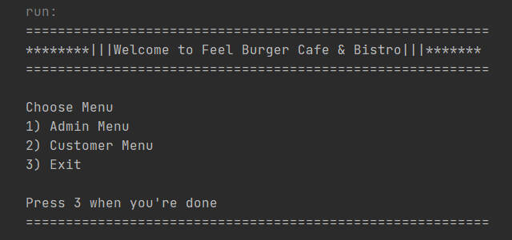

**Admin menu** – add new food items to the master list, show all food items, generate a report for the total food orders and back to the main menu.

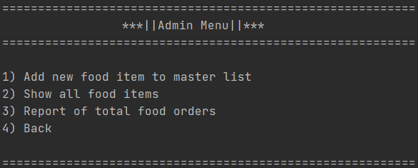

**Customer menu** – show all items in the menu, place order and back to the main menu.

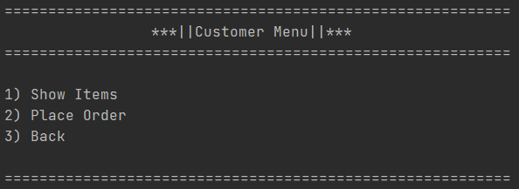

# 3. Pseudo code

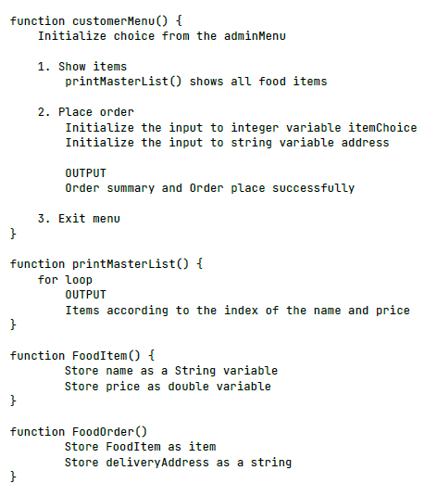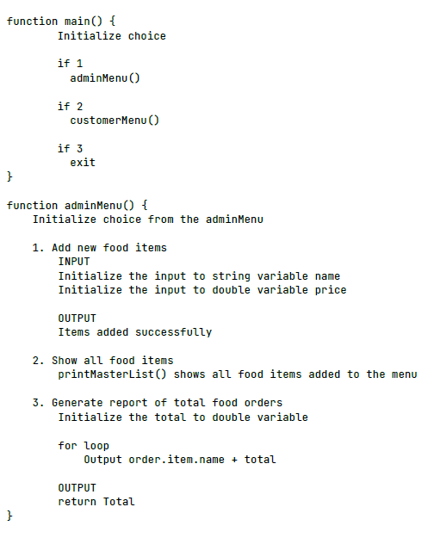The Food Ordering System was designed using Pseudo code.

# 4. Question 2 – Vehicle Service Center Management System

This is an overview on how we developed the Vehicle Service Center Management System.

**Main menu** - choose from admin menu if you are the admin or customer menu if you are the customer

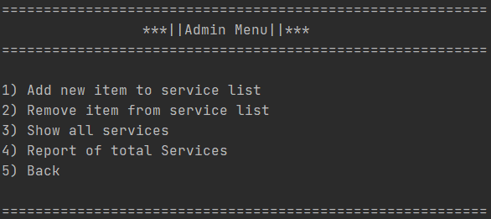

**Admin menu** – the admin can add or remove new items to the services list. Also can show all services. Generate a report on total services.



**Customer menu** – customer can view all services and select the services they want. Then the customer confirm the services. Once the confirmation is done, the system will generate an invoice based on the service and the prices.

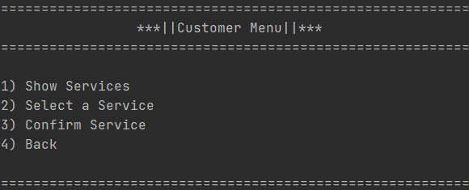

# 5. UML for Vehicle Service Center Management System

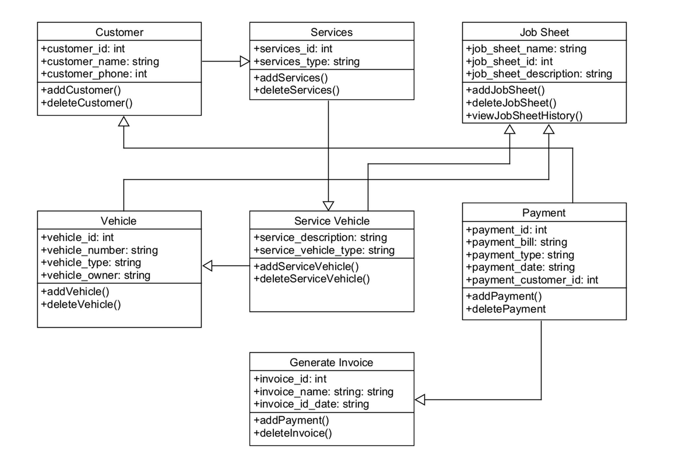

# 6 – Conclusion

Our systems are designed and developed to be user friendly and efficient. The systems are designed using UML and Pseudo code to simplify the systems functions and user experience.

# 7. References

<https://www.tutorialspoint.com/uml/uml_class_diagram.htm>

<https://www.umlet.com/>

<https://www.javatpoint.com/pseudocode-java#:~:text=In%20Java%2C%20a%20term%20used,an%20algorithm's%20cooked%2Dup%20representation>.

<https://www.unf.edu/~broggio/cop2221/2221pseu.htm>

<https://www.geeksforgeeks.org/arraylist-in-java/>